SWARNANDHRA COLLEGE OF ENGINEERING & TECHNOLOGY
[AUTONOMOUS]
Seetharampuram, NARSAPUR-534 280
B. Tech IV Semester

BUILDING PLANNING AND DRAWING

Unit-1

1. Explain the importance of building bye laws?
2. What is meant by aspect, prospect, circulation and grouping? Explain its importance?
3. What are the classifications according to building bye-laws and explain?
4. Explain the objectives of building byelaws.
5. Explain in detail the following:
(a) Floor area ratio (b) Building byelaws
6. What are the objectives of building byelaws?
7. Write briefly about Open Space Requirements of buildings
8. Explain the importance of wall thickness in byelaws of buildings
9. Explain the consideration of the height of buildings as per building bye-laws?

SWARNANDHRA COLLEGE OF ENGINEERING & TECHNOLOGY
[AUTONOMOUS]
Seetharampuram, NARSAPUR-534 280
B. Tech IV Semester

BUILDING PLANNING AND DRAWING

Unit-2

1. Write classification of buildings? Also explain any three types of buildings?
2. What are the factors to be considered by planner prior to planning of a residential building?
Explain one of them in detail.

3. Give the standard dimensions for the following rooms of a residential building
(i) Veranda (ii) Bed room (iii) Sick room
4. Explain in detail the various requirements of different rooms and their grouping
5. List out different purposes of rooms in a residential building?

6. Explain the standard requirements of the following in a residential building.
i) Bed Room
ii) Drawing cum Dining Room
7. Explain clearly different principles involved in planning a residential building?8.What are the
different points normally given consideration while planning a residential building? Explain
with examples?
9. Write the minimum standards for various parts of buildings and explain?

10. Write the importance and necessity in planning of hospitals?

SWARNANDHRA COLLEGE OF ENGINEERING & TECHNOLOGY
[AUTONOMOUS]
Seetharampuram, NARSAPUR-534 280
B. Tech IV Semester

BUILDING PLANNING AND DRAWING

Unit-3

1. Explain different principles used while planning a hospital in rural areas?
2. Design the layout of a hotel building constructed in a city?
3. What are the factors to be considered in the design of a bank building? Explain the principle of planning a hospital
4. Explain in detail with neat sketch about planning of bank building?
5. Write the importance and necessity in planning of industrial buildings?
6 . Write the importance and necessity in planning of hotels and motels?
7. Plan a Post office in a village in 250 sq.m area. Take all environmental and economic factors
into consideration while planning?
Draw plan of the above building? Assume all the necessary data suitably.
8. Write the importance and necessity in planning of educational institutes?

SWARNANDHRA COLLEGE OF ENGINEERING & TECHNOLOGY
[AUTONOMOUS]
Seetharampuram, NARSAPUR-534 280
B. Tech IV Semester

BUILDING PLANNING AND DRAWING

Unit-4

- Draw Flemish bond of 1½, 2 brick way (rough sketch only)
- Draw sign convention for the following materials:
i) Brick ii) Stone iii) Zinc iv) Earth
- Draw the sign conventions of R.C.C, COPPER ALLOY, BRICK MASONRY and SAND FILLING, and TIMBER various sections?
- Explain and draw the neat sketch of English bond.
- Draw the plan, elevation and isometric view of odd course of 2 brick Flemish bond?
- Differentiate between stone and brick masonry?
- Draw sign conversion for i) Brick ii) Glass iii) Stone iv) Timber v) Concrete?
- Draw the plan, elevation and isometric view of odd course of 2 brick Flemish bond?
- Differentiate between stone and brick masonry?
- Draw sign conversion for i) Brick ii) Glass iii) Stone iv) Timber v) Concrete?

SWARNANDHRA COLLEGE OF ENGINEERING & TECHNOLOGY
[AUTONOMOUS]
Seetharampuram, NARSAPUR-534 280
B. Tech IV Semester

BUILDING PLANNING AND DRAWING

Unit-5

- Draw plan and sectional elevation of a paneled door of size 1.2X2.1m. Indicate all
Features?
- Draw a detailed elevation of a king post truss of 5m clear span. Indicate all
Features?
    - Draw plan for
    - Coupled roof
    - Collar roof
- Draw a detailed elevation of a king post truss of 6 m clear span. Indicate all
Features?
- Draw to a suitable scale the elevation and details of a queen post truss of span 12000 mm. Assume suitable dimensional of the components and indicate all the details.
- Classify doors? Explain about any four type of doors
- Clearly differentiate between king post and queen post truss? Explain different features?
- Classify windows? Explain about any four type of doors?
- Explain different features of king post truss?
- Explain clearly difference between Battened, paneled and flush doors?
- Explain the different features of Queen post truss?

SWARNANDHRA COLLEGE OF ENGINEERING & TECHNOLOGY
[AUTONOMOUS]
Seetharampuram, NARSAPUR-534 280
B. Tech IV Semester

BUILDING PLANNING AND DRAWING

Unit-6

1.Draw plan, elevation and section of a building by using given line diagram and assume suitable
dimensions for foundation, slab thickness, lintel thickness, parapet wall thickness etc.
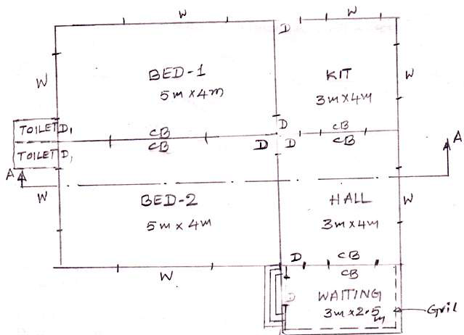
2.Draw plan, elevation and section for the below Figure 1 line diagram and use suitable
Dimensions.
3. Draw plan, elevation and section for the below line diagram and assume suitable dimensions.

4. Draw the plan and sectional elevation along AB for the LINE diagram given below
(Figure 2).Assume suitable Foundation details

5.Draw the dimensioned plan and elevation for the given line plan. Assume all
suitable data.

*****

