SWARNANDHRA COLLEGE OF ENGINEERING & TECHNOLOGY
SEETHARAMPURAM, NARSAPUR-534280
DEPARTMENT OF CIVIL ENGINEERING
SUBJECT: DESIGN & DRAWING OF STEEL STRUCTURES
Question Bank
UNIT- I
CONNECTIONS

- (a)Explain different types of welds with sketches.
(b)Explain the following for fillet weld considering I.S specification;
i) size of weld, ii) Throat thickness and iii) Length of weld
- (a)Design a lap joint b/w the two plates each of width 120mm,if the thickness of one plate is 16mm and the other is 12mm.The joint has to transfer a design load of 160kN, use 20 mm bolts of grade 4.6.The plates are of Fe410 grade.
(b)Determine the depth of the fillet weld required to join a plate bracket with flange of a stanchion as shown in figure (Load = 50 kN)
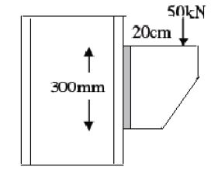

- (a)Explain about fillet welds. What are the Advantages and Disadvantages of Welded Connections?
(b)Design a suitable longitudinal fillet weld to connect 120x8mm plate to 150x10mm plate to transmit a pull equal to the full strength of small plate. Assume welding is to be made in the field.
- Design a suitable longitudinal fillet weld to connect the plates as shown in fig to transmit a pull equal to full strength of small plate. Given plates are 12mm thick grade of plates Fe410 and welding to be made in work shop.
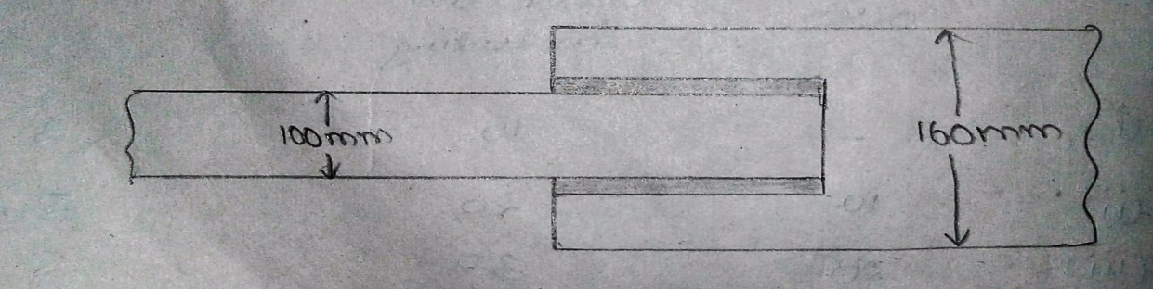

SWARNANDHRA COLLEGE OF ENGINEERING & TECHNOLOGY
SEETHARAMPURAM, NARSAPUR-534280
DEPARTMENT OF CIVIL ENGINEERING
SUBJECT: DESIGN & DRAWING OF STEEL STRUCTURES
UNIT- II
TENSION MEMBERS AND COMPRESSION MEMBERS

- Determine the tensile strength of a angle section 100 x 75 x 10 mm of roof truss that connected to a gusset plate 16 mm thick by 4 no.s 20 mm diameter power driven rivets arranged in one row along the length of member. Assume short leg of the angle kept outstanding. Assume any data if necessary.
- Design a steel column to carry an axial load of 2000kN. The length of the column is 5.0 m and effectively held in both ends.
- The main tie of a roof truss has to carry a maximum axial tension of 200kN. Design a suitable section for the member as per IS Specifications. Design the section as two angles placed back to back of a gusset plate.
- Design a single angle section for a tension member of a roof truss to carry a factored tensile force of 225kN. The member is subjected to possible reversal of stress due to the action of wind. The length of the member is 3m, use 20mm shop bolts for grade 4.6 for the connection.
- A single unequal angle ISA 9060, 6mm is connected to a 10mm gasset plate at the ends with 5 numbers of 16mm bolts to transfer tension as shown in fig. Determine the design tensile strength of the angle if the gasset is connected to 90mm length
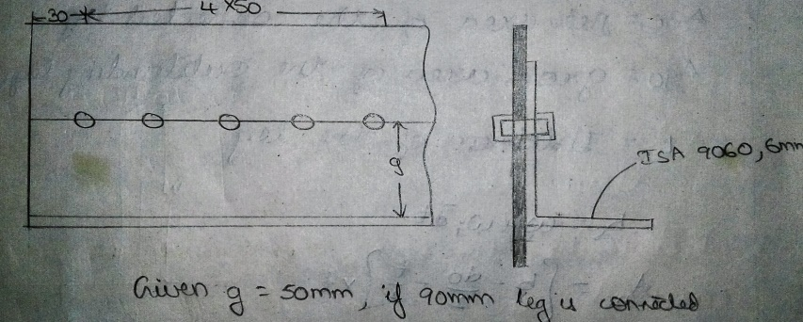
- Design a single angle strut connected to gasset plate to carry 180KN factored load. The length of the strut b/w centre to centre intersection is 3m.

SWARNANDHRA COLLEGE OF ENGINEERING & TECHNOLOGY
SEETHARAMPURAM, NARSAPUR-534280
DEPARTMENT OF CIVIL ENGINEERING
SUBJECT: DESIGN & DRAWING OF STEEL STRUCTURES
UNIT- III
DESIGN OF COLUMNS

- Design a built-up column 7 m long to carry a factored axial load of 1000 kN. The column is restrained in position but not in direction at both the ends. Design the column with two channels placed toe-to-toe. Provide single lacing system. Assume Fe 410 grade. Draw the cross-section and sectional elevation of the column.
- Design a built up column of the effective length of 5m to carry an axial load of 900kN using lacing and design the connections. Take f_{y}=250N/mm².
- A column section ISHB 300 @ 618 N/m is to be spliced. The factored design loads are axial load over the column is 450 KN, shear force is 100 KN and bending moment is 30 KN-m. Design a suitable column splice. Assume ends are milled. Use steel grade of Fe 410.
- Design a laced column with two channels back to back of length 10 m to carry an axial factored load of 1400 KN. The column may be assumed to have restrained in position but not in direction at both ends.
- Design a laced column with two channels back to back is subjected to 1500KN. Effective length is 7m, also design single laced system.
- Explain design procedure of lacings with neat sketch.

SWARNANDHRA COLLEGE OF ENGINEERING & TECHNOLOGY
SEETHARAMPURAM, NARSAPUR-534280
DEPARTMENT OF CIVIL ENGINEERING
SUBJECT: DESIGN & DRAWING OF STEEL STRUCTURES
UNIT- IV
DESIGN OF COLUMN FOUNDATIONS
- Design a slab base for column ISHB 300@577 N/m carrying an axial factored load of 1000KN, M20 concrete is used for the foundation. Provide welded connection between column and base plate.
- Design a gusseted base for a column ISHB 350@710N/m with two plates of450mmx20mm carrying a factored load of 3600KN. The column is to be supported on concrete pedestal to be built with M20 concrete.
- Design a gusseted base to carry an axial factored load of 3000KN. The column is ISHB 450@855N/m with two 250x22mm cover plates on either side. The effective height of column is 5m. The column is to rest on M20 concrete pedestal.
- Design a gusseted base to carry an axial factored load of 3000 kN. The column is an ISHB450 @855 N/m with two 250×22 mm cover plates on either side. The effective height, of column is 5 m. The column is to rest on a M20 concrete pedestal. Draw to scale the plan and elevation.
- Design a slab base for a column ISHB 350 @ 710.2 N/m subjected to an factored axial compressive load of 1500 KN for the following conditions i) Load is transferred to the base plate by direct bearing of column flanges. The base rests on concrete pedestal of grade M 20. Draw a neat sketch showing all the details.
- Design a base plate for an ISHB 350 column to carry a factored load of 1200 KN. Assume Fe 410 grade steel and M 25 concrete.

SWARNANDHRA COLLEGE OF ENGINEERING & TECHNOLOGY
SEETHARAMPURAM, NARSAPUR-534280
DEPARTMENT OF CIVIL ENGINEERING
SUBJECT: DESIGN & DRAWING OF STEEL STRUCTURES
UNIT- V
BEAMS
- Design a simply supported beam of span 4 m carrying a reinforced concrete floor capable of providing lateral restraint to the top compression flange. The uniformly distributed load is made up of 20kN/m imposed load and 20 kN/m dead load (section is stiff against bearing). Assume Fe 410 grade steel.
- Design a simply supported beam of 9m effective span carrying a load of 40KN/m. The depth of beam should not exceed 450mm. The compression flange of beam is laterally supported
- Design a laterally unrestrained beam to carry a uniformly distributed load of 30kN/m. The beam is unsupported for a length of 3m and is simply placed on longitudinal beams at its ends.
- Design a simply supported beam of span 6m carrying a reinforced concrete floor capable of providing lateral restraint to the top compression flange. The uniformly distributed load is made up of 30 KN/m imposed load and 30 KN/m dead load (section is stiff against bearing). Assume Fe 410 grade steel.
- Design a laterally unsupported beam for the following data.
Effective span: 4m
Maximum bending moment: 550 KN-m
Maximum shear force: 200kN
Steel grade: Fe 410

SWARNANDHRA COLLEGE OF ENGINEERING & TECHNOLOGY
SEETHARAMPURAM, NARSAPUR-534280
DEPARTMENT OF CIVIL ENGINEERING
SUBJECT: DESIGN & DRAWING OF STEEL STRUCTURES
UNIT- VI
DESIGN OF PLATE GIRDER, DESIGN OF GANTRY GIRDER

- Design a plate girder of span 24m and carries a factored load of 35KN/m and avoid stiffeners.
- Design a plate girder of effective span of 25m and live load is 45Kn/.Use end bearing stiffeners.
- Design a welded plate girder to carry a superimposed load of 50kN/m and two concentrated loads of 200kN each at one third points of the span. The effective span of the plate girder is 24m. Assume that the girder is laterally supported throughout its length. The yield strength of the steel of both the flanges and the web is 250MPa. Draw cross section of plate girder and end portions of the plate girder
- Design a simply supported gantry girder to carry an electric overhead travelling crane, given: (i) Span of gantry girder = 6.5m, (ii) Span of crane girder = 16m, (iii) Crane capacity = 250kN, (iv) Self weight of crane girder excluding trolley = 200kN, (v) Self weight of trolley =50kN, (vi) Minimum hook approach = 1.0m, (vii) Distance between wheels = 3.5m and (viii) Self weight of rails = 0.3kN/m.
- Explain step by step procedure to design a gantry girder as per IS code.

