Swarnandhra
College of Engineering & Technology (A), Narsapur
Department of Civil Engineering
Subject: ES&C
UNIT-I
1. Prepare the approximate cost of building project (group Houseing)
i) No.of houses = 150
ii) Plinth area of each dwelling = 600m2
iii) Plinth area rate = Rs. 5,000/-per m2
iv) Cost of water supply & sanitary arrangements @12½%
v) Electrification at 7½% of cost of builing.
vi) Cost of roads & Lawns @5%
vii) Cost of P.S.& contingencies @4%
2. Prepare a rough cost estimate of a cinema theatre which accommodate 1700 seats. The cost of construction including all provisions is Rs.6000/- per seat.
3. What are the methods of preparation of approximate estimates and explain briefly.

Swarnandhra
College of Engineering & Technology (A), Narsapur
Department of Civil Engineering
Subject: ES&C

UNIT-II

- Describe the procedure for calculation of rate per unit Cu.m of first Class brick in superstructure with 20x10x10 cm brick with cement sand mortar 1:6.
- Perform the rate analysis for 12 mm thick plaster with cement mortar (1:6).
- Describe the procedure for the calculation of rate per unit cum of Cement Concrete 1:2:4 for RC work excluding reinforcement and form work.
- Explain the procedure of Rate Analysis and situations when Rate Analysis is needed to be carried out for items in public works.

Swarnandhra
College of Engineering & Technology (A), Narsapur
Department of Civil Engineering
Subject: ES&C
UNIT-III

- The formation width of road embankment is 9.0m. The side slopes are 2.5:1. The depths along the center line of road at 50.0m intervals are 1.2,1.1,1.4,1.2,0.9,1.5 and 1.0m.It is required to calculate the quantity of earthwork by
(i) Prismoidal rule. (ii) Trapezoidal rule.
- Explain any three methods of calculation of earth work for road.
- Prepare bar bendin schedule for the beam shown in below figure and also estimate steel quantity from it.
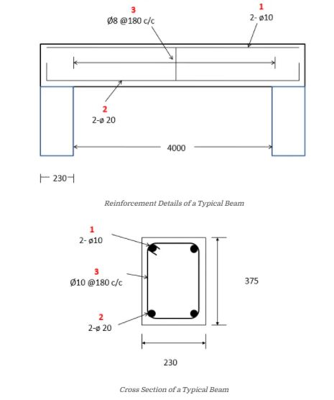

Swarnandhra
College of Engineering & Technology (A), Narsapur
Department of Civil Engineering
Subject: ES&C

UNIT-IV

- Explain the following specifications?
a) General Specifications b) Detail specifications
- a) What is valuation? Explain briefly about the methods of valuation.
b) List out the general conditions of contract in tender document.
- a) Explain the standard specification of class ‘B’ type buildings.
b) Write briefly on salvage value and market value.
- Write detailed specifications for cement concrete (1:4:8) and stone masonry in C.M. 1:6.

Swarnandhra
College of Engineering & Technology (A), Narsapur
Department of Civil Engineering
Subject: ES&C
UNIT -V
- Estimate the quantities of following items of a two roomed building given in Fig 1(a)&(b) by Individual wall method.
a. Earthwork in excavation in foundation trench
b. Lime concrete in foundation
c. First class brick work in 1:6 cement mortar in foundation and plinth
d. 2.5 cm thick DPC (1:2:4) with water proofing compound
e. 1st class brick work in cement mortar superstructure
The dimensions of doors, windows and selves are
Door D = 1.20 m × 2.10 m.
- Estimate the quantities of following items by using short wall and long wall method from fig.2(a) and 2(b).
(i) Earth work excavation for foundation
(ii) Plain cement concrete (1:4:8) in foundation
(iii) Plastering with C.M 1:3 inside only
Note: Make suitable assumptions where necessary
- Estimate the quantities of following items by using short wall and long wall
method from fig.3(a) &3(b)
(a) Earth work excavation for foundation
(b) Plain cement concrete for foundation
(c) Brick masonry in C.M 1:6 for superstructure with deductions
Note: Make suitable assumptions where necessary

Fig. 1

Fig 3a
Fig.3b

Swarnandhra
College of Engineering & Technology (A), Narsapur
Department of Civil Engineering
Subject: ES&C

UNIT -VI
- Estimate the quantities of following items of a two roomed building given in Fig 1(a)&(b) by Centre line method.
a. Earthwork in excavation in foundation trench
b. Lime concrete in foundation
c. First class brick work in 1:6 cement mortar in foundation and plinth
d. 2.5 cm thick DPC (1:2:4) with water proofing compound
e. 1st class brick work in cement mortar superstructure
The dimensions of doors, windows and selves are
Door D = 1.20 m × 2.10 m.
- Estimate the quantities of following items by using centre line method from fig.2(a) and 2(b).
(i) Earth work excavation for foundation
(ii) Plain cement concrete (1:4:8) in foundation
(iii) Plastering with C.M 1:3 inside only
Note: Make suitable assumptions where necessary
- Estimate the quantities of following items by using centre line method from fig.3(a) &3(b)
(a) Earth work excavation for foundation
(b) Plain cement concrete for foundation
(c) Brick masonry in C.M 1:6 for superstructure with deductions
Note: Make suitable assumptions where necessary

Fig. 1

Fig 3a
Fig.3b

