SWARNANDHRA COLLEGE OF ENGINEERING & TECHNOLOGY
AUTONOMOUS
DEPARTMENT OF CIVIL ENGINEERING
Strength of Materials-I
QUESTION BANK
UNIT-1
- An axial pull of 35000N is acting on a bar consisting of three lengths as shown in Fig. If young’s modulus= 2.1*10⁵ N/mm², determine stresses in each section and total extension of the bar.

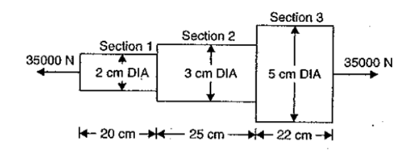
- A steel rod of 3cm diameter is enclosed centrally in a hollow copper tube of external diameter 5cm and internal diameter 4cm. The composite bar is then subjected to an axial pull of 45kN. If the length of each bar is equal to 15cm, determine the stresses in the rod and tube, and load carried by each bar.
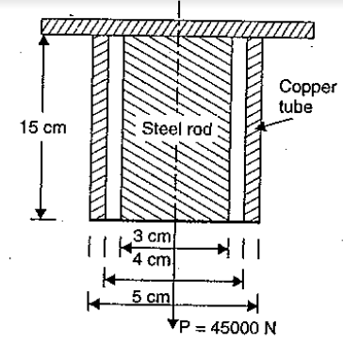
- A steel tube of 30mm external diameter and 20mm internal diameter enclose a copper rod of 15mm diameter to which it is rigidly joined at each end. If at a temperature of 20ºC there is no longitudinal stress, calculate the stresses in the rod and tube when the temperature is raised to 250ºC. If young’s modulus of steel and copper is 2.1*10⁵ N/mm² and 1*10⁵ N/mm² respectively. The value of coefficient of linear expansion for steel and copper is 11*10⁻⁶/ºC& 18*10⁻⁶/ºC.

- Deduce the expression for Strain Energy due to gradual and sudden applied loads.
- A rectangular plate made of steel is 4 m long and 20 mm thick and is subjected to an axial tensile load of 60 kN. The width of the plate varies from 30 mm at one end to 80 mm at the other end. Find the elongation, if E = 2x105 N/mm².
- A load of 120 N falls through a height of 20 mm on to a collar rigidly attached to the lower end of a vertical bar 1.2 m long and of 1.5 cm2 cross-sectional area. The upper end of the vertical bar is fixed. Determine: (i). Maximum instantaneous stress induced in the bar, and (ii). Maximum instantaneous elongation. Take E=2x105 N/mm².
UNIT-2
- A cantilever of length 5m is loaded as shown in Fig. Draw the S.F and B.M diagrams for cantilever.
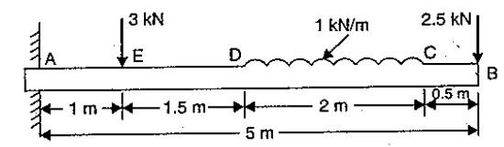

- Draw the S.F and B.M diagrams for simply supported beam with an eccentric point load?
- A simply supported beam of length 10m carries the uniformly distributed load and two point loads shown in Fig. Draw the S.F and B.M diagrams for the beam. Also calculate the maximum B.M.
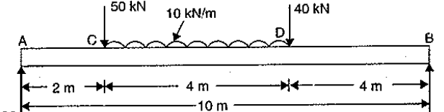
- Deduce the relation between Shear force and bending moment.
- An overhanging beam is shown in figure 1. Draw the S.F and B.M diagrams.
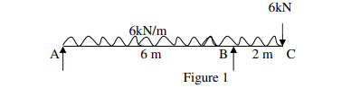
- A horizontal beam, 26 m long, carries a uniformly distributed load of 12 kN/m over the whole length and concentrated load of 32 kN at 1 m from the right end. Draw the diagrams of S.F and B.M inserting the principal values.

UNIT-3

- Explain the theory of simple bending and write the assumptions for theory of simple
Bending?
- Write the expression for Bending Stress?
- A cast iron beam of I-Section as shown in Fig, the beam is simply supported span of 5m. If the tensile stress is not to exceed 20 N/mm², find the safe uniformly load which the beam can carry. Find also the maximum compressive strength.

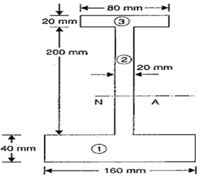
- Calculate the maximum flexural stress induced in a cast iron (C.I) pipe of external diameter 40 mm, internal diameter 20 mm and of length 4 m, when the pipe is simply supported at its ends and carries a point load of 80 N at its center.
- A beam is simply supported and carries a uniformly distributed load of 50 kN/m for the whole span. The section of the beam is rectangular having depth as 500 mm. If the maximum stress in the material of the beam is 130 N/mm2 and moment of inertia of the section is 7x108 mm4 , find the span of the beam.
- Derive the bending equation from fundamentals using standard notation.
UNIT-4
- A simply supported beam of span L, carrying a point load P at 0.3L from left support. Determine the mid-span displacements and slopes at the supports, using the method of integration.
- A rectangular R.C simply supported beam of length 2m and cross section 100mmX200mm is carrying a uniformly distributed load of 10KN/m through its span. Find the maximum slope and deflection. Take E= 2 x 10⁴N/mm²
- A beam 7m long carries a uniformly distributed load of 20 kN/m run throughout its length. The beam is supported over a span of 5m with overhang of 2m one side. Determine the slope and deflection at the cantilever end E = 200 GPa, I= 802 mm⁴.
- A simply supported beam of span 5 m, carrying a point load of 8 kN at a distance of 3 m from the left end. Find (i) slope at the left support, (ii) deflection under the load and (iii) maximum deflection. Take E= 2x105 N/mm2 and I = 2 x108 mm⁴. Use double integration method.
- A simply supported beam of span 6 m loaded point load of 14 kN at its centre, in addition to the UDL of 6 kN/m for the whole span. Find slopes at the supports and maximum deflection. Use double integration method.
- Find the slope and deflection of simply supported beam of span L, carrying (i) a point load P at the centre, (ii) a U.D.L of w kN/m over the entire span, using the moment area method.
UNIT-5
- Derive the formula for the thickness of the thin cylindrical shell and solve the following problem. A thin cylindrical shell of 1 m diameter is subjected to an internal pressure of 1 N/mm2. Calculate the suitable thickness of the shell, if the tensile strength of the plate is 400 N/mm2 and factor of safety is 4.
- A compound cylinder is made by shrinking a cylindrical of external diameter 300 mm and internal diameter of 250 mm over an another cylindrical of external diameter 250 mm and internal diameter 200 mm. The radial pressure at the junction after shrinking is 8 N/mm². Find the final stresses sent up across the section, when the compound cylinder is subjected an internal fluid pressure of 84.5 N/mm².
- Find the thickness of metal necessary for a cylindrical shell of internal diameter 160 mm to withstand an internal pressure of 10 N/mm². The maximum hoop stress in the section is not to exceed 38 N/mm².
- Derive the Lames equations from the fundamentals in a thick cylindrical shell for the given radii (r1 and r2) and internal fluid pressure, p.
- Deduce the circumferential stress equation for a thin cylindrical shell subjected to an internal pressure of intensity ‘p’ with a thickness ‘t’ and diameter ‘d
- A spherical shell of internal diameter 750 mm and of thickness 9 mm is subjected to an internal pressure of 1.8 N/mm². Determine the increase in diameter and increase in Volume. Take E= 2x105 N/mm2 , 1/m =0.33.

