
SWARNANDHRA
COLLEGE OF ENGINEERING & TECHNOLOGY
(Autonomous)

SEETHARAMPURAM, NARASAPUR-534280
DEPARTMENT OF COMPUTER SCIENCE AND ENGINEERING
Regulation :R16 Course Code/Course Title: 16CS5E03/COMPUTER GRAPHICS
QUESTION BANK
UNIT-1
1. a) Classify the applications of computer Graphics. [05M]
b) Write DDA line drawing algorithm. [05M]

2. a)Write the steps of Bresenham’s line drawing algorithm. [05M]
b) Demonstrate Bresenham’s line drawing algorithm for the lines
with end point (2,3) and (12,15). [05M]
3.a) Explain scan- line polygon fill algorithm.
b)List the Steps of mid-point circle algorithm and Draw a circle with radius r = 4 with centre
as(6, 6) by using Bresenham’s circle drawing algorithm [10M]

4. a) Explain a) Raster scan systems. [05M]
b) Random Scan systems. [05M]

UNIT-2

1. Explain the fallowing transformations with examples [10M]
i)Translation
ii)Rotation
iii)scaling
iv)Reflection & shear

2. a) Write Composite transformations of rotation with respect to pivot point. [05M]
b) Write Composite transformations of fixed point scaling. [05M]

3.a) Describe Cohen-Sutherland line clipping algorithm. [05M]
b) Explain Sutherland-Hodgeman polygon clipping algorithm. [05M]

4. a) Describe about viewing pipeline. [05M]
b) Write about window- to -viewport coordinate transformations. [05M]

UNIT-3

- a) Discuss about polygon surfaces and polygon mess [05M]
- Classify different quadric surfaces. [05M]

2 a) Define spline. Differentiate interpolation spline and approximation spline. [05M]
b) Illustrate the methods to specify spline Specifications. [05M]

- a) Describe Bezier surfaces. [05M]
b) Explain Hermite curve. [05M]
UNIT- 4

- Explain about fallowing 3-D transformation with equations [10M]
a) Translation and 3-D scaling
b) 3-D rotations with X, Y and Z axis.

2. Define projection ? and explain types of projection in detail with diagrams? [10M]
3 a) Formulate the Transformation matrix for Parallel and Perspective Projections [5M]
b) Differentiate parallel and perspective projections? [5M]

- a) Illustrate about viewport clipping. [5M]
b) a) Define 3D viewing and explain in brief about 3D viewing Pipeline. [5M]

UNIT- 5

- a) Define visible surface Detection. Classify visible surface detection methods. [05M]
b) Explain back-face detection algorithm. [05M]

- Summarize the steps of depth-Buffer Algorithm and write the formulas for calculating depths. [10M]
- Explain scan-line algorithm for visible surface detection with an example. [10M]

- Describe BSP - tree method and construct BSP tree for below image. [10M]

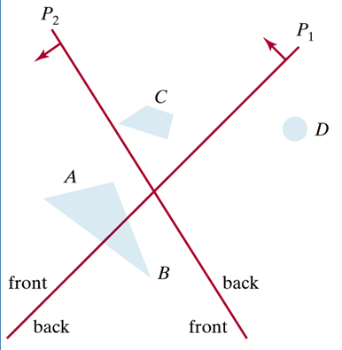

UNIT- 6
- Define computer animation. Describe the steps involved in the process of animation and
method of controlling animations. [10M]

- a) Write about computer animation functions. [05M]
b) Write about raster animations. [05M]

- Define rendering & describe the below
i)Key frames ii)Generation in-between frames) [10M]

- Describe Computer Animation Languages. [10M]

