|  |  |
| --- | --- |
| SWARNA_mULTIlOGO | **Swarnandhra College of Engineering & Technology**  **(Autonomous)**  Seetharampuram, **NARSAPUR**, **W.G. Dt., 534 280.**  **Department of Mathematics**    **DISCRETE MATHEMATICS (16MA3T01)** |
|  | **QUESTION BANK (R-16)** |

UNIT-I

**Mathematical Logic**

1. (i) Define converse, contrapositive and inverse of an implication with example. [ 03 M ]

(ii) Let p, q, r be the propositions

P: You have the flu

q: You miss the final examination

r: You pass the course

Write the following propositions into English sentences 1. p→q 2. ¬p→r 3. q→¬r 4. pvqvr

5. (p→¬r)v(q→¬r) [ 02 M ]

2. Define principal disjunctive normal form and Show that the principal disjunctive normal form of

pv(¬p→ (qv(¬q→r))) is ∑(1,2,3,4,5,6,7) [ 05 M ]

3. Define principal conjunctive normal form and Show that the principal conjunctive normal form of

(p→(qΛr)) Λ (¬p→(¬qΛ¬r)) is 𝝅 (1,2,3,4,5,6) [ 05 M ]

4. (i) Let p and q be the propositions

p: You drive over 65 miles per hour

q: You get a speeding ticket

Write these propositions using p and q and logical connectives.

(a) You do not drive over 65 miles per hour.

(b) You drive over 65 miles per hour, but you do not get a speeding ticket.

(c) You will get a speeding ticket, if you drive over 65 miles per hour.

(d) If do not drive over 65 miles per hour, then you will not get a speeding ticket.

(e) Drive over 65 miles per hour is sufficient for getting a speeding ticket. [ 02 M ]

(ii) Obtain p.d.n.f and p.c.n.f of the following formula  [ 03 M ]

5. (i) Define tautology, contradiction and contingency? [ 03 M ]

(ii) Prove that the following formula is a tautology (a) (((P∨ $\sim$ Q) → R) $→$ S) ∨ $\sim$ (((P∨ $\sim$ Q)→R) $→$ S). [02 M ]

(b) ((P→ (Q→R)) → ((P→Q) → (P→R))) (c) (P→ (Q→R) ↔ ((PΛQ) →R)

6.(i) Define NAND, NOR and Exclusive OR with truth tables. [03 M ]

(ii) Prove that NAND and NOR are commutative but not associative. [ 02 M ]

7. (i) Show that $(A⨁B)∨(AB)AB$ [ 03 M ]

(ii) Show that RΛ(P∨Q) is a valid conclusion from the premises P∨Q, Q→R, P→M and [ 02 M ]

8. (i) Show that R→S can be derived from the premises P→ (Q→S), $\sim$ R $∨$ P and Q. [ 03 M ]

(ii) Prove the following logical equivalence (a) ((P∨Q)Λ(P∨ $\sim$ Q)) ∨Q $⇔$ P∨Q

(b) (¬P Λ (¬Q Λ R))V(Q Λ R)V(P Λ R) $⇔$ R (c) (P→R)Λ(Q→R) $⇔$ (PVQ) →R [ 02 M ]

9. Prove or Disprove the validity of the following arguments:

1. If a baby is hungry, then the baby cries. If the baby is not mad, then he does not cry. If a baby is mad, then he has a red face. Therefore, if a baby is hungry, then he has a red face. [03 M]
2. If the client is guilty, then he was at the scene of the crime. The client was not at the scene of the crime. Hence, the client is not guilty. [02 M]
3. Verify that the following argument is valid by using the rule of inference.
4. If joe is a mathematician, then he is ambitious.

If joe is an early riser, then he does not like oatmeal.

If joe is ambitious, then he is an early riser.

Hence, if joe is a mathematician, then he does not like oatmeal. [02 M]

(ii) If Clifton does not live in france, then he does not speak French.

Clifton does not drive a datsun.

If Clifton lives in france, then he rides a bicycle.

Either Clifton speaks French, or he drives a datsun.

Hence, Clifton rides a bicycle. [03 M]

1. Construct truth table for following formulae, (a) (QΛ (P→Q)) →P (b) ¬(PV(QΛR)) ↔ ((PVQ) Λ (PVR)) (c) (P↔R) Λ(¬Q →S)
2. Define well formed formula. State De Morgan’s Laws. Show that (P→Q) is logically equivalent to (¬PVQ)

UNIT-II

**Predicate calculus**

1. Verify the validity of the following argument;

(i) “All men are mortal. Socrates is a man. Therefore Socrates is mortal.” [02 M]

(ii) Define quantification and explain different types of quantifications? [03 M]

2. Verify the validity of the following argument;

(i) “Lions are dangerous animals. There are Lions. Therefore there are dangerous animals.” [02 M]

(ii) Duke is a Labrador Retriever. All Labrador retriever likes to swim. Therefore Duke like to Swim. [03 M]

3. (i) Consider the propositions over the universe U= $\left\{-5,0,1,2,3,…….10\right\}$

P(x): $x^{2}$ <5, Q(x): x $≥$ 3, R(x): x is a multiple of 2, S(x): $x^{2}$ =25.

Find the truth sets of P(x), Q(x), R(x), S(x), P(x)ΛQ(x) [02 M]

(ii) Translate the following statements into symbols using quantifiers, variables and predicate symbols.

(a) All birds can fly.

(b) Some babies are illogical.

(c ) Not all birds can fly.

1. Some men are giants.
2. There is a student who likes mathematics but not history. [03 M]

4. (i) Explain Free and Bound variables with an example? [ 02M ]

(ii) Show that the premises “A student in this class has not read the book,” and “Everyone in this class passed the first exam” imply the conclusion “Someone who passes the first exam has not read the book”. [03 M]

5. (i) Prove that ( $x) \left[P\left(x\right)Q\left(x\right)\right](x) P\left(x\right)(x) Q(x)$ [ 02M ]

(ii) Verify the validity of the following argument:

All integers are rational numbers.

Some integers are powers of 2.

Therefore some rational numbers are powers of 2. [03 M]

6. (i) Prove that $[\left(x\right)(P\left(x\right)→Q\left(x\right)]∧[\left(x\right)(Q(x)→R\left(x\right)]\left(x\right)(P\left(x\right)→R\left(x\right))$ [02 M]

(ii) Show that the premises “everyone in discrete mathematics class has taken a course in computer science” and “Marla is a student in this class” imply the conclusion “Marla has taken a course in Computer Science”. [03 M]

7. Verify the validity of the following argument

(i) All Boys are players. Sachin is a boy. Therefore Sachin is a player. [02 M]

(ii) If two sides of a triangle are equal, then two opposite angles are equal. Two sides of a

triangle are not equal. Therefore, the opposite angles are not equal. [03 M]

8. (i) Let P(x) denote the statement “x is a professional athlete” and Q(x) denote the statement

“x plays soccer”. The domain is the set of all people. Write each of the following statements in

English. (a) $∀x \left(P\left(x\right)→Q\left(x\right)\right)$

(b) $∃x \left(P\left(x\right)∧Q\left(x\right)\right)$

(c) $∀x \left(P\left(x\right)∨Q\left(x\right)\right)$ [02 M]

(ii) Write the negation of each of the above propositions both in symbols and in words. [03 M]

9. Prove are disprove the validity of the following argument:

Every living thing is a plant or an animal.

David’s dog is alive and it is not a plant.

All animals have hearts.

Hence David’s dog has a heart. [05 M]

10. Prove are disprove the validity of the following argument:

All humming birds are richly colored.

No large birds live on honey.

Birds that do not live on honey are dull in color.

Hence, humming birds are small. [05 M]

UNIT – III

**Set theory & Relations**

1. Explain about the following properties of a binary relation in a set X .Give an example of each i) Reflexive ii) symmetric iii) transitive iv) irreflexive v) Anti symmetric [05 M]
2. (a) What are the properties of the relation  and also write R as a set. [02 M]

(b)Let A = {1,2,3,4} and R = {(1,1), (1,2), (1,3), (2,1),(2,2),(2,3),(3,1),(3,2),(3,3),(4,4)}.Is R is an equivalence relation? If yes, then find the partition of A induced by R. [03 M]

3. Define equivalence relation with an example? Let

be a relation on X,

Show that R is an Equivalence relation on X. [05 M]

1. (a)Let is S=  and the relation R on S Where R= .

Draw the graph of the relation and give its relation matrix [03 M]

(b) How many relations are there on a set with “n” elements? If a set A has “m” elements and a

set B has “n” elements, how many relations are there from A to B? If a set A= {1, 2},

determine all relations from A to A. [02 M]

5. (a) Define a Poset and Draw the Hasse diagrams of the following Posets

i)  Where 

ii)  Where  “/” : divides [05 M]

1. What is a compatibility relation? Let the compatibility relation on a set

 be given by the following matrices

1. (ii)

 

Draw the graph and find the maximal compatibility blocks of the relation. [05 M]

1. (a) Let the relation  on the set {1, 2, 3}. Find the transitive closure of R.

(b) If A = { 1, 2, 3, 4} and R is a relation on A defined by

R = { (1, 2), (1, 3), (2, 4), (3, 2), (3,3), (3, 4) } . Find $R^{2} and R^{3}$. [05 M]

Write down their di-graphs

8. Given S= { 1, 2, 3, 4 } and relation R on S defined by R= { (1, 2), (4, 3), (2, 2 ), (2, 1), (3,1) }

Show that R is not transitive .Find a relation ${ R}_{1}⊇R$ such that $R_{1}$ is transitive . Can you

find another relation $R_{2}⊇R$ which is also transitive? [05 M]

1. (a)Define pigeonhole principle and generalized pigeonhole principle? [02 M]

(b) Show that in a group of 367 people there must be one pair with same birthday. [03 M]

1. Determine the number of primes not exceeding 100 ? [05 M]

UNIT-IV

**Recurrence Relations**

1). Explain the methods of solving Recurrence relations with suitable examples.

2). Solve the recurrence relation using substitution method

(i) an = an-1+ f(n) for n (ii) an = c an-1 + f(n) for n (iii) an = 2an/2+ (n-1) for n >2 where a1=0

3). Using Generating function solves the recurrence relation

(a) an-7an-1+10an-2=0 for n≥2 with a0=10,a1=41.

(b) an-6an-1+12an-2-8an-3=0, n≥3.

(c) an-7an-1+10an-2=0 for n≥2.

(d) an-9an-1+26an-2-24an-3 = 0 for n≥3.

(e) (K)-9T(k-1)+26T(k-2)-24T(k-3)=0, for k≥3 with T(0)=0,T(1)=1,T(2)=10. 4). Solve the recurrence relation Fn=Fn-1+Fn-2, n≥2 with F0=0,F1=1.

5). Solve the recurrence relation

(a) S (k)-3S (k-1)-4S (k-2) =4k, k≥2.

(b) 

(c) $a_{n}-a_{n-1}=3\left(n-1\right)where n≥1 and where a_{0}=2$

(d) $a_{n}-{5a}_{n-1}+6a_{n-2}=3\left(n-1\right)where n≥2 and where a_{0}=1, a_{1}=5$

(e)

6).

(a) an+22-5an+12+6an2=7n, a0=1, a1=1.

(b)

UNIT-V

**Graph Theory**

1. How many vertices will the following graphs have if they contain (a) 16 edges and all vertices of degree

(b) 21 edges, 3 vertices of degree 4 and the other vertices of degree 3.

2. a) what is the largest possible number of vertices in a graph with 35 edges and all Vertices of degree at

least 3 .b) Is the sequences d = ( 1,2,3,4,4,5,6,7 ) is Graphic?

3. a) Define the following and give one example each i) Sub graph ii) Spanning Sub graph iii) Induced

Sub graph iv) Simple Graph v) Multi Graph

b) State first theorem of Graph theory and Show that in any graph there are even number of odd degree

Vertices.

4 a) Define Graph Isomorphism. Write the necessary and sufficient conditions for existence of isomorphism

Between two graphs

b) What are the different ways of representing a graph in computer memory with examples?

5. Define the following Special Graphs (i) Complete Graph (ii) Cycle Graph (iii) Path Graph

(iv) Bipartite Graph (v) Complete Bi-partite vi) complement of a graph with examples

6. Define the terms a) Euler path, Euler Circuit & Eulerian graph b) Hamiltonian path , Hamiltonian

Cycle and Hamiltonian graph with example.

7. a) Give an example for graph having Eulerian and Hamiltonian circuits.

b) Write the Rules for constructing Hamilton paths and cycles

9) Show that the following graphs are isomorphic or not.

(a) b)

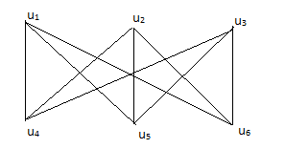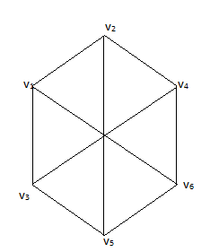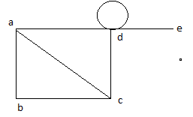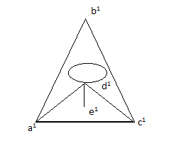

` G1 G2 G1 G2

c) d)

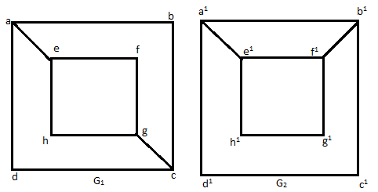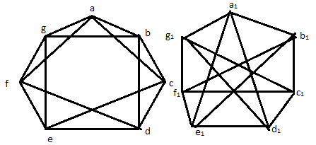

10) Find the Euler paths, circuits if exists of the following graphs.

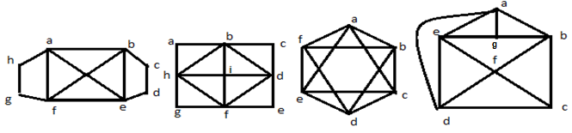

10) Find the Hamiltonian paths, circuits if exists of the following graphs.

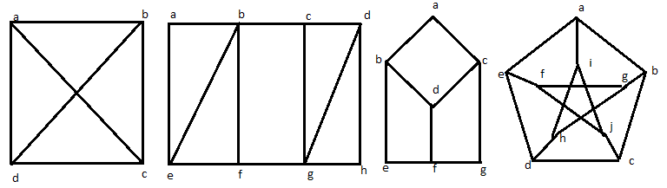

UNIT-VI

**Graph Theory and Applications**

1. a) Define a planar Graph with examples.

b) Show that complete graph $K_{5}, complete bi partitegraph K_{3,3}$ are non planar.

1. Define Chromatic Number. Find the Order, Size, and Chromatic Number of the following Graphs $i.K_{n }, ii. K_{m,n} iii. C_{n} iv. P_{n }v. W_{n} vi N_{n } vii. T_{n}$

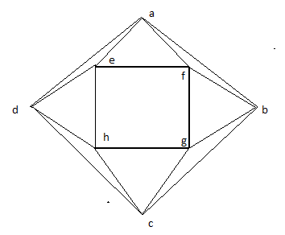 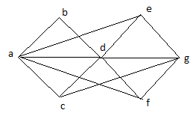 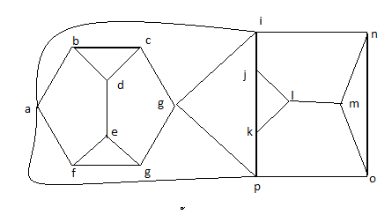

1. a) Draw the non directed different trees on 6 vertices

b) Write a kruskal’s algorithm with an example

1. a) Define i) Tree ii) Spanning Tree iii) Minimal Spanning Tree iv) Weighted graph with examples.

b) Write Prim’s algorithm with an example.

1. a) Define Binary tree, complete binary tree and regular binary tree with examples.

b) Draw all regular binary trees i) with exactly 7 vertices ii) with exactly 9 vertices.

1. Explain BFS and DFS algorithms with an example.
2. a) Draw the spanning tree for the following graphs using BFS Algorithm.

b) Draw the spanning tree for the following graphs using DFS Algorithms.

(i) (ii)

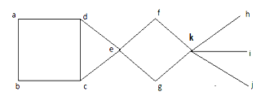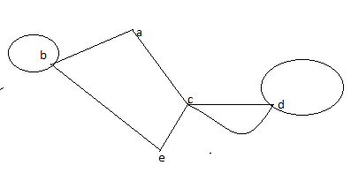

(iii)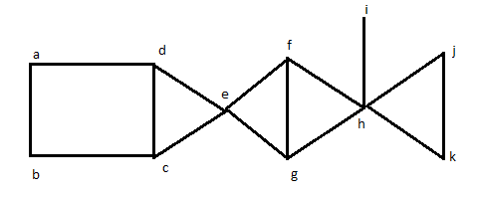(iv)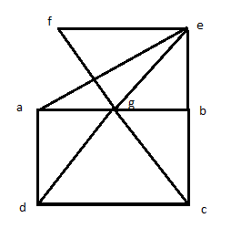

1. a) Determine the cost of minimum spanning tree by using kruskal’s algorithm

b) Determine the cost of minimum spanning tree by using prims’s algorithm

