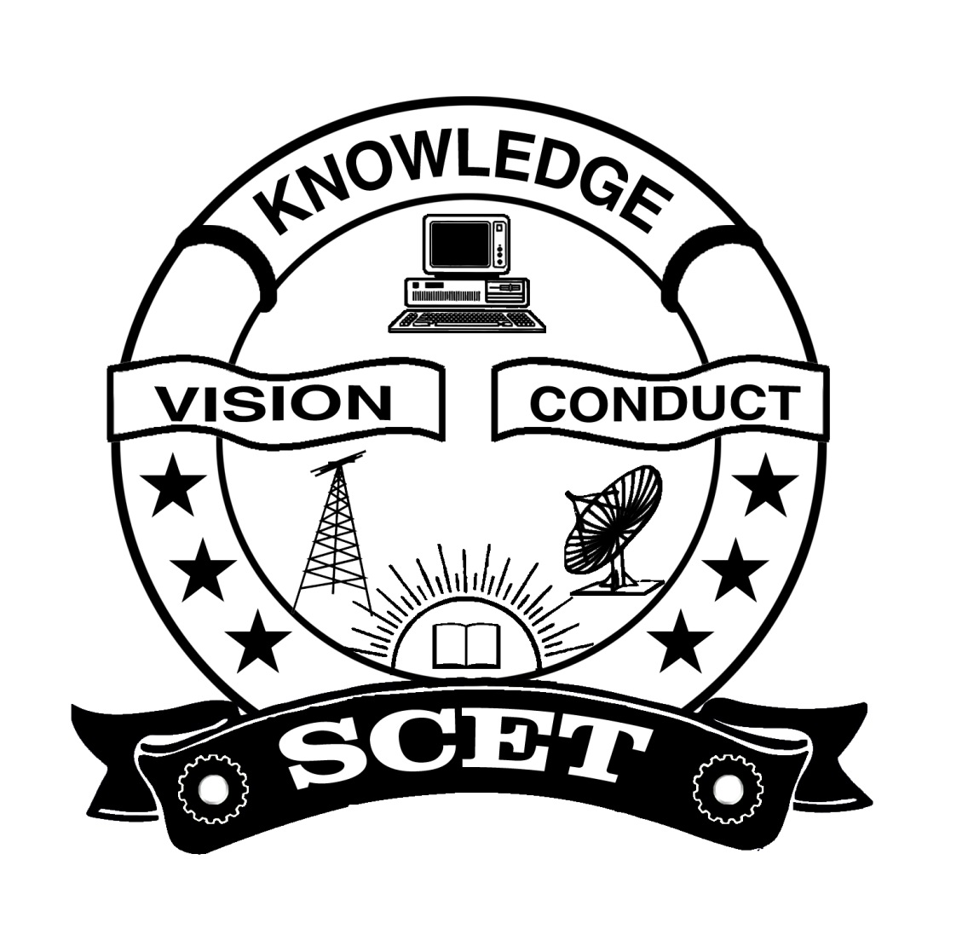
SWARNANDHRA COLLEGE OF ENGINEERING & TECHNOLOGY
AUTONOMOUS
Accredited by National Board of Accreditation, AICTE, New Delhi
Accredited by NAAC with “A” Grade-3.32/4.00 CGPA,
Recognised under 2(f) & 2(B) of UGC Act 1956, Approved by AICTE,
Permanently Affiliated to JNTUK, Kakinada
SEETHARAMPURAM, NARSAPURAM-534 280, W.G.DT.,

B Tech I/II SEMESTERS
ENGINEERING CHEMISTRY
(Common for All Branches)
PROPOSED SYLLABUS

COURSE OUTCOMES
At the end of semester, the students will be able to
CO1: Explain the impurities present in raw water, problems associated and how to avoid them (K2)
CO2: Explain the advantages of Polymers in daily life (K2)
CO3: Explain the theory of construction of battery and fuel cells and theories of corrosion and
prevention methods. (K2)
CO4: Differentiate conventional and non-conventional energy sources and their advantages and
disadvantages. (K2)
CO5: Identify the usage of advanced materials in day to day life (K2)

UNIT I: WATER TECHNOLOGY [9 Hours]

Part-A
Hard water-Types of hardness-Units of Hard Water-Disadvantages of hard water-Determination of hardness by EDTA complexometric method.
Portable water- its specifications-steps involved in purification of water (Sedimentation, Filtration, Disinfection)-chlorination, break point of chlorination.
Boiler Feed Water-Boiler troubles: Scale and sludge-priming and foaming-boiler corrosion-caustic embrittlement.
Part-B
Industrial Water Treatment: Softening methods: zeolite process-ion exchange process.
Brackish water treatment (desalination methods): Reverse osmosis - electro dialysis.

Learning Outcomes: At the end of this unit, the students will be able to Explain
The impurities present in raw water, problems associated with them and how to avoid them

UNIT-II: POLYMERS AND COMPOSITE MATERIALS [9 Hours]

Part-A
Polymers-degree of polymerization-functionality-preparation, properties and applications of individual polymers-Bakelite-PVC-Poly styrene.
Plastics: Types (thermosetting and thermoplastic)-compounding of plastics-moulding Process. (Injection moulding, Compression moulding, Extrusion moulding, Transfer moulding)

Part-B
Rubbers and elastomers: Introduction-natural rubber-vulcanization of rubber-synthetic rubbers-Buna-N, Buna-S.
Composite materials: Fiber reinforced plastics-biodegradable polymers-biomedical polymers, Recycling of e-waste.

Learning Outcomes: At the end of this unit, the students will be able to
- Outline the properties of polymers and various additives added and different methods of
forming plastic materials.
- Explain the preparation, properties and applications of some plastic materials.
- Discuss natural and synthetic rubbers and their applications.

UNIT III: ELECTRO CHEMICAL CELLS AND CORROSION [12 Hours]
Electrochemical Cells: Introduction–single electrode potential - electrochemical cell-electrochemical series and applications. Reference electrodes-standard hydrogen electrode and calomel electrode-construction of glass electrode. Batteries: Construction, working and cell reaction of primary (dry cell) and Secondary (Pb acid and Li-ion) battery. Fuel cells (H₂-O₂, Methanol-Air cells).
Corrosion: Cause and consequences of corrosion-theories of corrosion (Chemical and Electrochemical corrosion)-types of corrosion (Galvanic, Differential aeration (waterline and pitting corrosion), stress Corrosion). Factors influencing rate of corrosion-nature of metal-nature of corrosive atmosphere. Corrosion Prevention methods: Cathodic protection-Sacrificial anodic method-Impressed voltage method. Metallic coatings: Galvanization-Tinning-Electro plating-Electro less plating.

Learning Outcomes: At the end of this unit, the students will be able to
- Explain the theory of construction of battery and fuel cells.
- Categorize the reasons for corrosion and study some methods of corrosion control.

UNIT IV: CONVENTIONAL AND NONCONVENTIONAL ENERGY RESOURCES [9 Hours]

Conventional energy sources: Classification and characteristics of fuels-solid, Liquid and gaseous fuels-advantages and disadvantages-calorific value-higher and lower calorific values-construction and working of bomb calorimeter-analysis of coal-proximate and ultimate analysis-numerical problems related to bomb calorimeter, Dulong’s formula and coal analysis-petroleum refining-cracking – petrol and diesel knocking – octane number and cetane number – gaseous fuels – Natural gas – CNG - LPG

Non-conventional energy sources: Solar energy: Advantages-disadvantages of solar cells-construction and working of photo voltaic cell -Introduction to hydro power-geo thermal power-tidal and wave power.
Learning Outcomes: At the end of this unit, the students will be able to
- Differentiate conventional and non-conventional energy sources and their advantages and disadvantages.
- design sources of energy by different natural sources

UNIT V: CHEMISTRY OF MATERIALS [9 Hours]
Part-A
Nano materials: Introduction-sol-gel method-characterization by SEM and TEM methods- carbon nanotubes and fullerenes: Types, preparation and applications
Semiconductors: Preparation ( Distillation, Zone refining )
Part-B
Cement: Constituents of cement -Setting and Hardening of cement - Decay of Cement.
Refractories: Definition of refractory-classification and properties of refractoriness-applications of refractories.
Learning Outcomes: At the end of this unit, the students will be able to
- Outline the awareness of materials like nanomaterials and fullerenes and their uses.
- Explain the techniques that detect and measure the surface properties of materials.
- Illustrate the commonly used industrial materials.

Text Books:
T1. A Text Book of Engineering Chemistry - N. Y. S. Murthy, V. Anuradha & K. Ramana Rao, Maruthi Publications. (2018)
T2. A Text Book of Engineering Chemistry - K. Sesha Maheswaramma, Mridula Chugh, Pearson Publications (2018).
Reference Books:
R1. Engineering Chemistry – Jain & Jain, Dhanpat Rai Publishing Company (Latest Edition)
R2. Text Book of Engineering Chemistry - Shashi Chawla, Dhanpat Rai & Co. (P) Limited
((Latest Edition))
R3. Chemistry –Prasanta Rath, Subhendu Chakroborthy, Cengage publications (2018)

