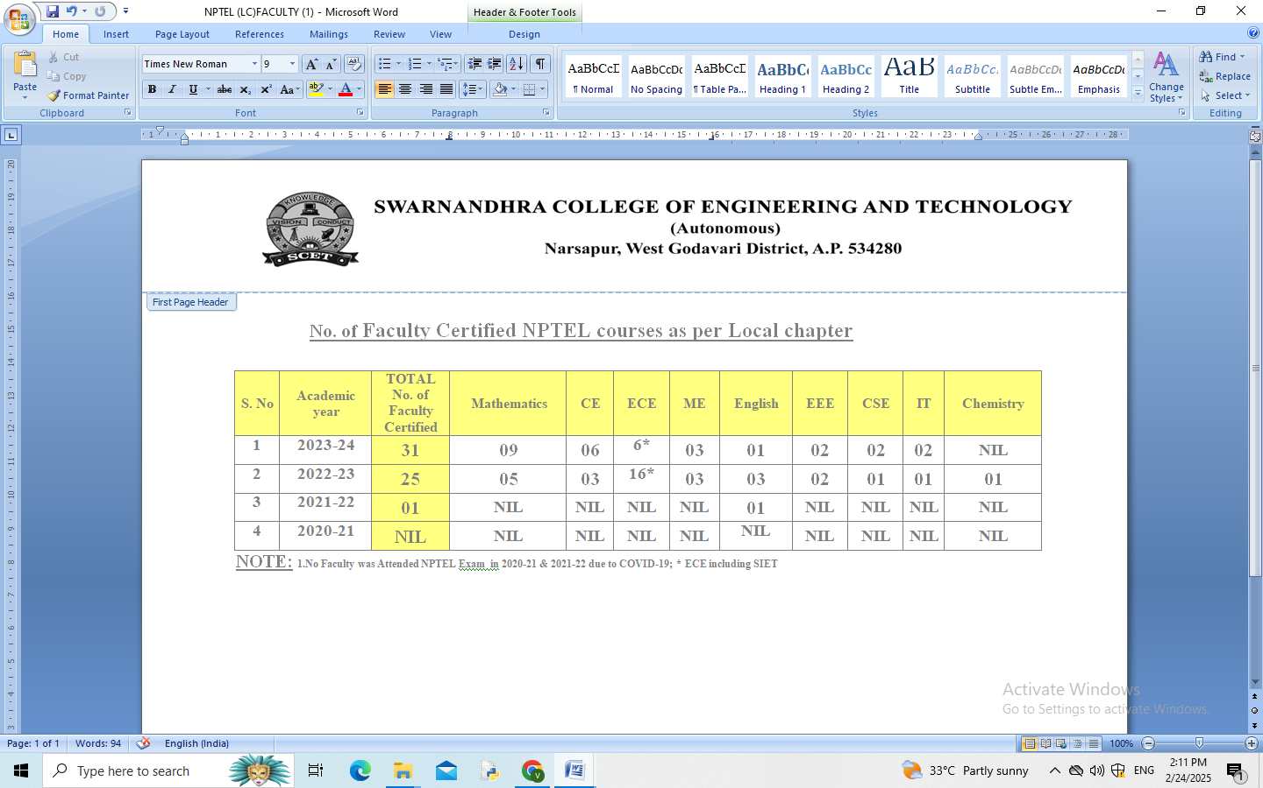
DEPARTMENT OF S&H
List of Faculty NPTEL Certified During January- June 2026
S.No | Faculty Name | Subject | Grade
1 | Dr Mary Victoria Eathakoti | Mathematical Foundations of Machine Learning | Certified
2 | Durga Bhavani Pulaparthi | Graph Theory | Elite
3 | Ravi Venkata Lakshmi | Probability and Stochastic for Finance | Certified
4 | Narayana P V | Natural Language Processing | Elite
5 | Kottu Dhana Narasimha murthy | Probability for Computer Science | Elite
6 | Kottu Dhana Narasimha murthy | Data Science for Engineers | Elite
7 | K Ramana Rao | Introduction to the Psychology of Language | Elite
8 | K Ramana Rao | Introduction to Psychology | Elite
9 | G V R S Sai Krishna | Literature and Life | Elite
10 | Thripureswari Picchika | Introduction to Psychology | Elite
11 | Srinivasa Rao Kadali | Bioinorganic Chemistry | Elite- Gold
12 | M Prasanthi | Metallocene and Metal-carbene based Organometallic Compounds as Industrially Important Advanced Polyolefin Catalyst | Certified
13 | V Sekhar Babu Vadlapati | Bioinorganic Chemistry | Certified
14 | P V Kumari Chellaboina | Data Base Management System | Elite
15 | Karem Swathi | Cloud Computing | Certified
16 | Gudisa Swapna | Problem Solving Through Programming in C | Certified
17 | Vinodh Choppala | Engineering Mechanics - Statics and Dynamics | Elite

CERTIFICATES
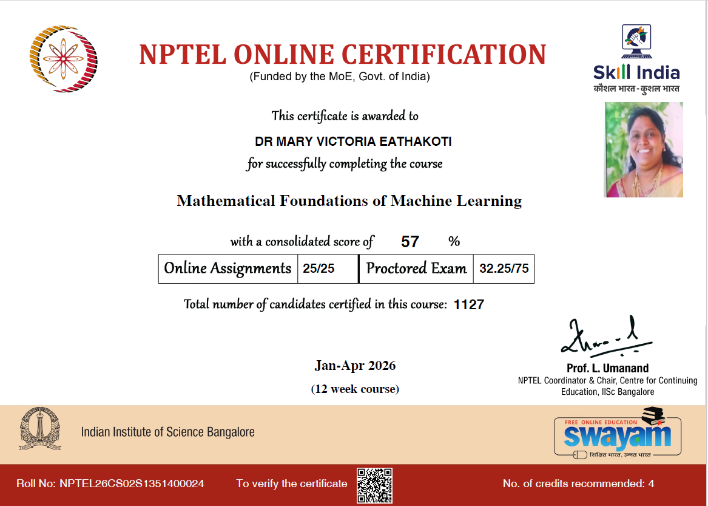 | 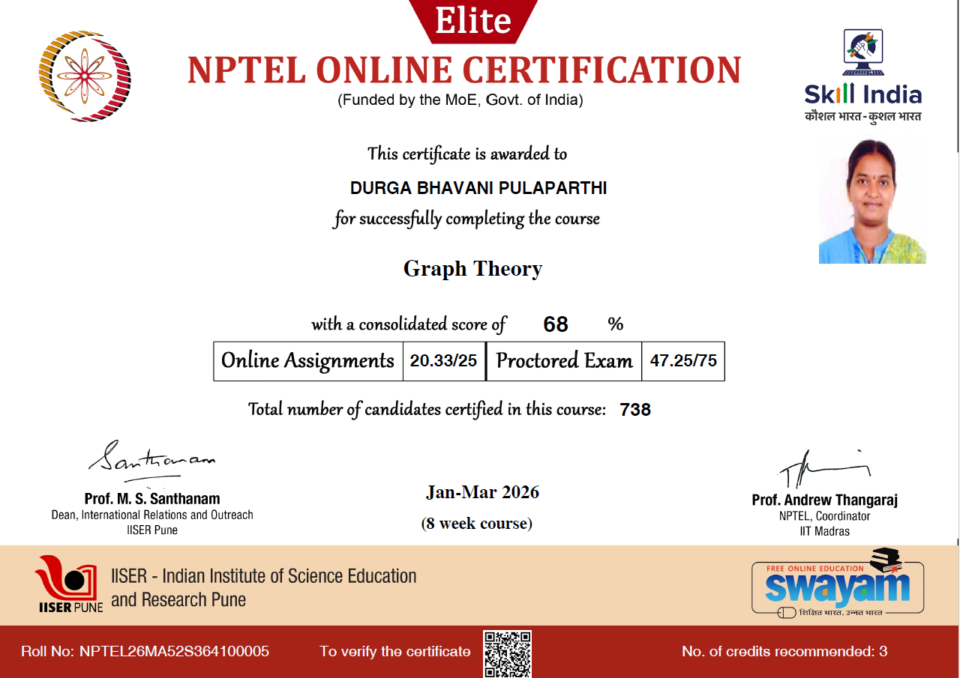
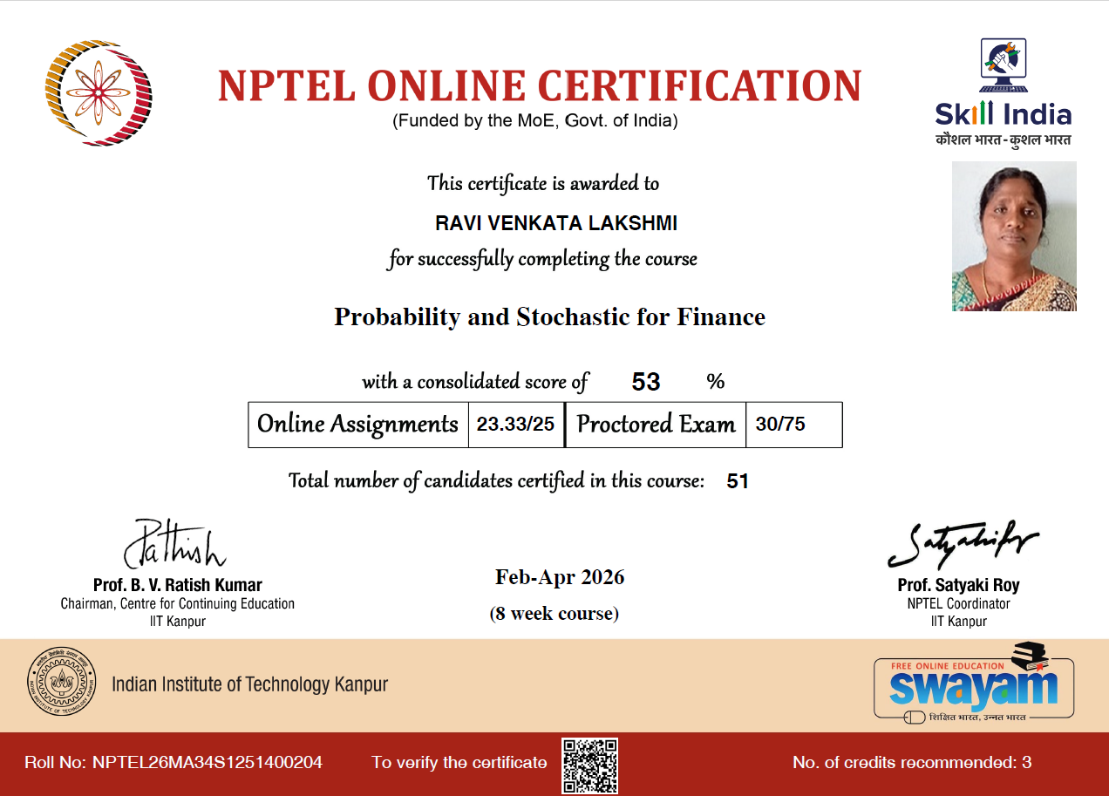 | 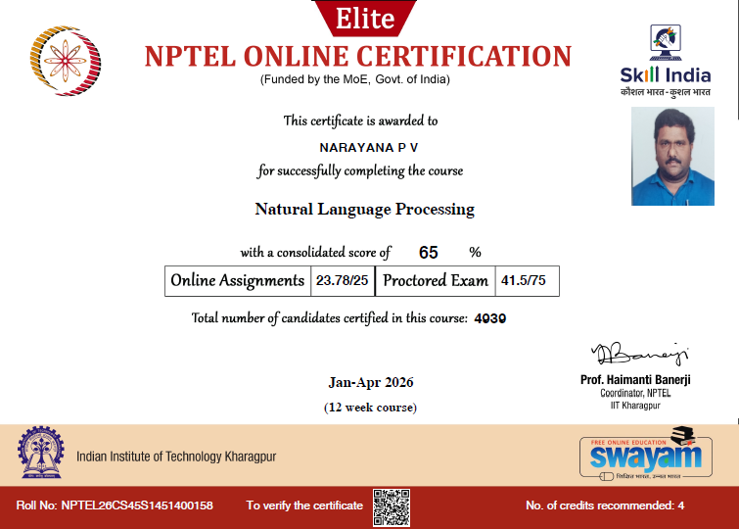
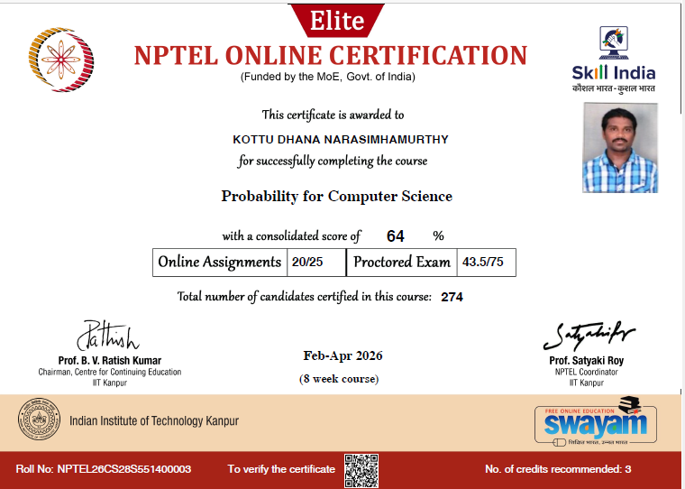 | 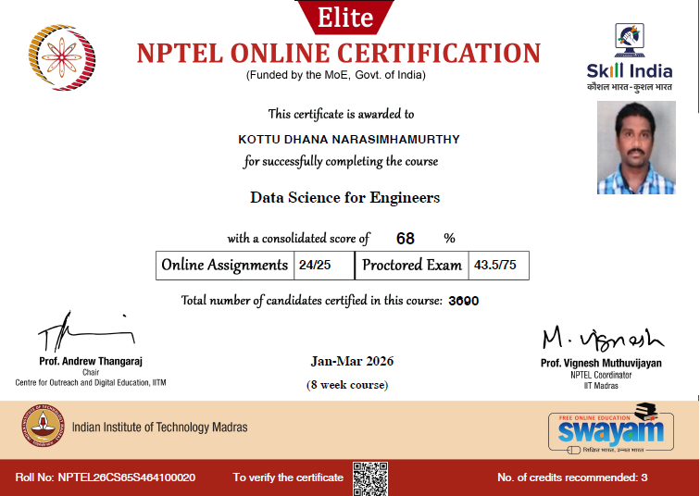
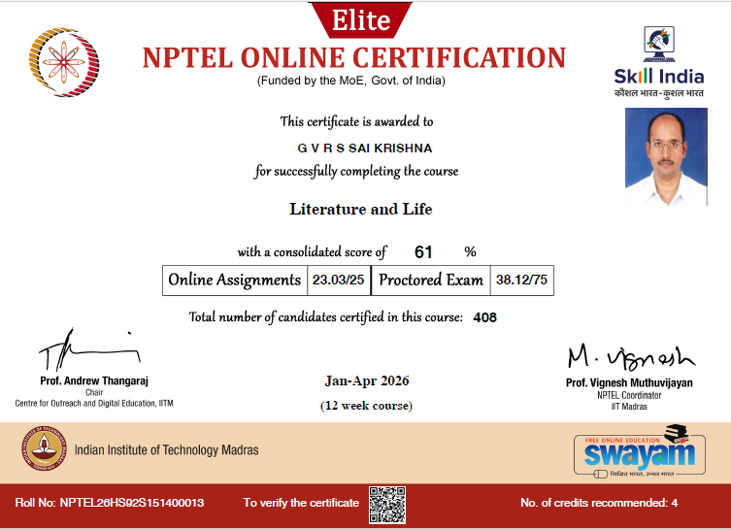  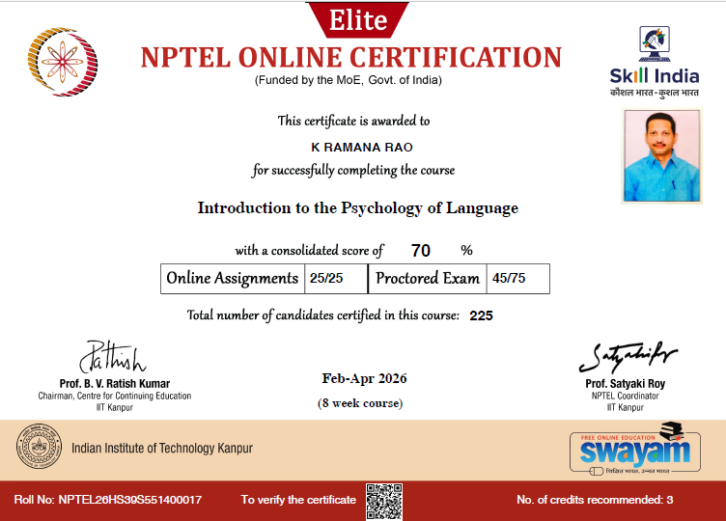 | 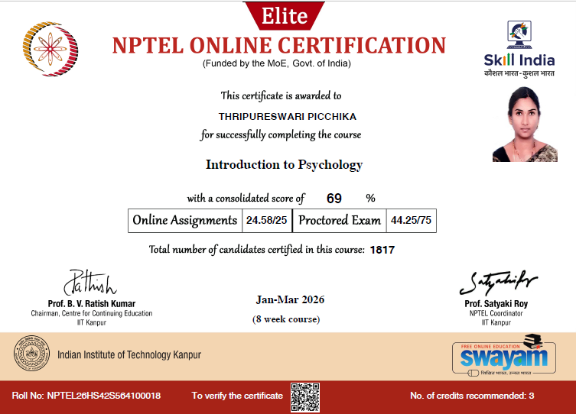  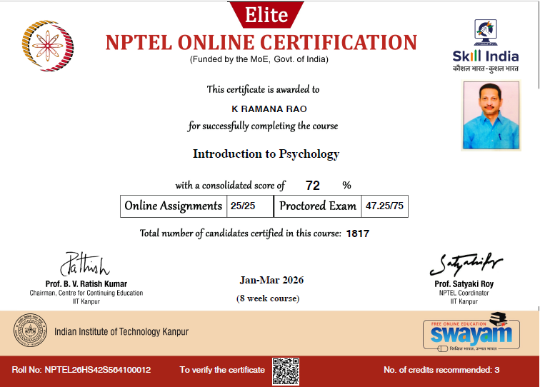
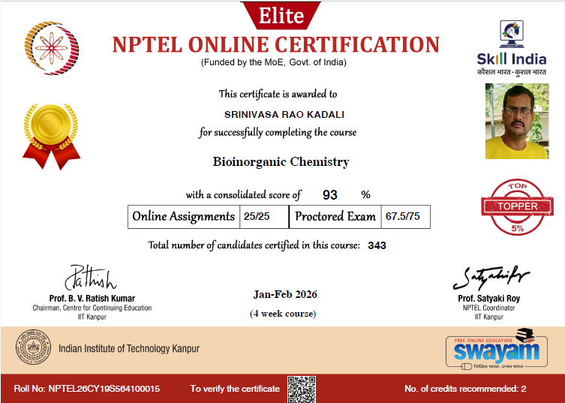 | 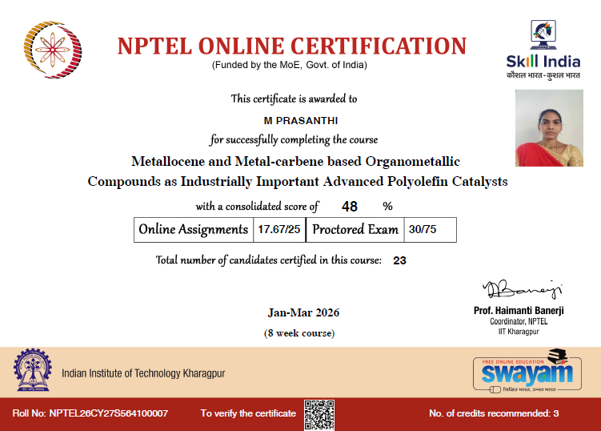
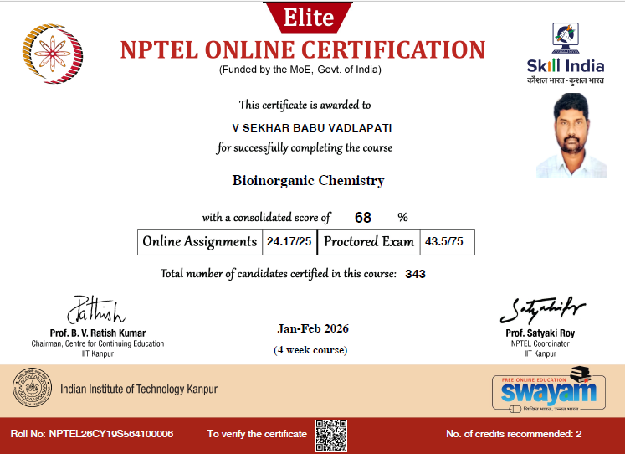 | 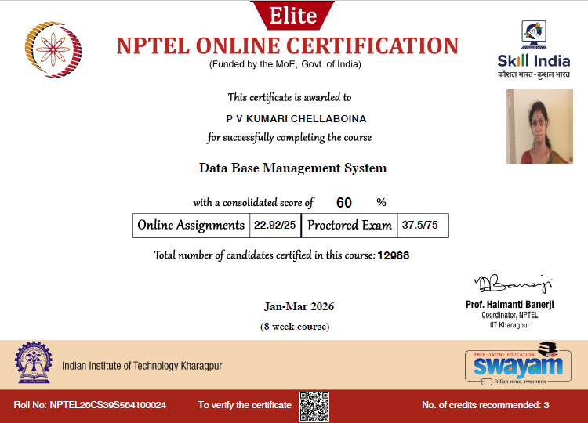
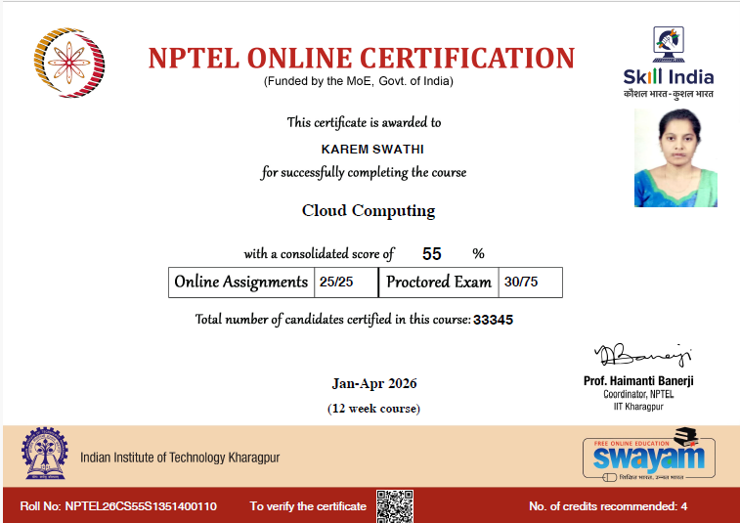  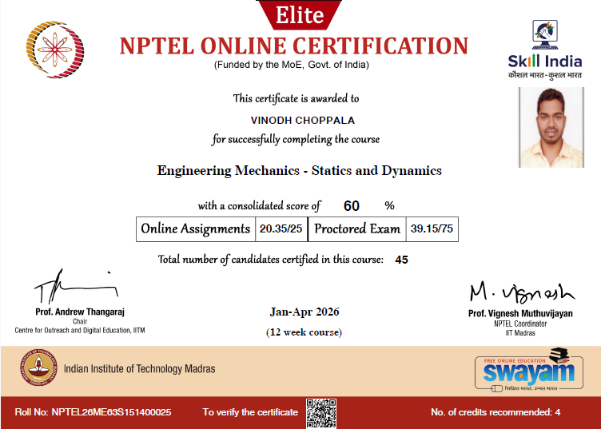 | 